# Team Kenshi

# JS Chess

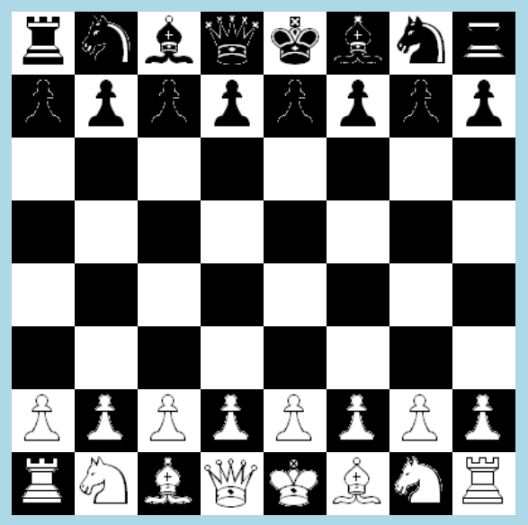

Content:

* List of all team members
* A short project description
* Git Repository

## Kenshi Team member list:

* Емрах Бекир (emrah.bekir in the student system )
* Ивайло Петров (Ivayl3 in the student system)
* Ивайло Христов (ivaylo.iliev.hr in the student system)
* Лазар Лазаров (LazarDL in the student system)
* Стефан Върбанов (varbanoff in the student system)
* Тихомир Архангелов (tisho in the student system)

## Git repository: <https://github.com/emrah-it/Kenshi>

# Short description

The application that our team decided to create is pretty self-explanatory. It’s a standard two player chess game. The task of our application is to serve as a local referee between two players or serve for training purposes more experienced players (at the time of writing the application still lacks a AI system).

Our project provides most anything a local multiplayer game of chess might require. It makes sure none of the players can make any invalid moves. It also highlights all fields a piece can move to once such is selected (the application allows change of the selected figure).

All pawns will turn to queens when they reach the end of the board. Players will be duly notified when their King or Queen is in danger. Although at this point we haven’t implemented key features like the clock and some simple animations, they should be present in the final version that is presented.

The dimensions of the board can easily be changed to accommodate all kinds of screen resolutions. The game should run correctly on all browsers above IE 8 (excluding).